Exploratory Audience Analysis:
How Audiences Respond to Masculinity Influencer Content in Nigeria and Kenya
Gates-Funded Research Project
Discourse Analysis of Audience Comments — Exploratory Phase
2026

1. Introduction
This report presents exploratory findings from a discourse analysis of audience comments in response to content produced by masculinity influencers in Nigeria and Kenya. It is a companion document to the Exploratory Content Findings report, which analyzes what creators say. This document analyzes how audiences respond — the ideological, emotional, and social work that audiences perform in comment sections, and what this reveals about the normative (describing or reinforcing what is considered standard or expected) effects of creator content in digital publics.
The analytical significance of audience comments lies in the fact that they are not passive reception. A comment section is a site of social production: audiences demonstrate their interpretations, negotiate positions with other commenters, perform community membership, and sometimes contest or resist the ideological frame of the content they are responding to. Reading comment sections as discourse, rather than as a simple measure of audience opinion, reveals the dynamics through which digital masculinity norms are collectively constructed, reinforced, and occasionally challenged.
The theoretical framework guiding this analysis is consistent with the content report: Connell and Messerschmidt's (2005) hegemonic masculinity (the dominant cultural ideal of manhood that others are measured against) and Glick and Fiske's (1996) ambivalent sexism (the combination of hostile attitudes toward women who challenge male authority and seemingly positive but controlling attitudes toward women who comply) provide the orienting lenses. However, the audience analysis adds a third dimension: the sociology of digital publics, in which comment sections function as micro-communities that may have their own norms, hierarchies, and dynamics distinct from those of the creator. The relationship between creator content and audience reception is not one of simple transmission; it is one of active, if asymmetric, co-production.
Data were drawn from 417 audience comments in Nigeria and 412 in Kenya, across four creators per country selected to represent both progressive and regressive content orientations. Comments were sampled from specific source posts, and the analysis attends to both individual comment content and comment-thread dynamics where threads were available.
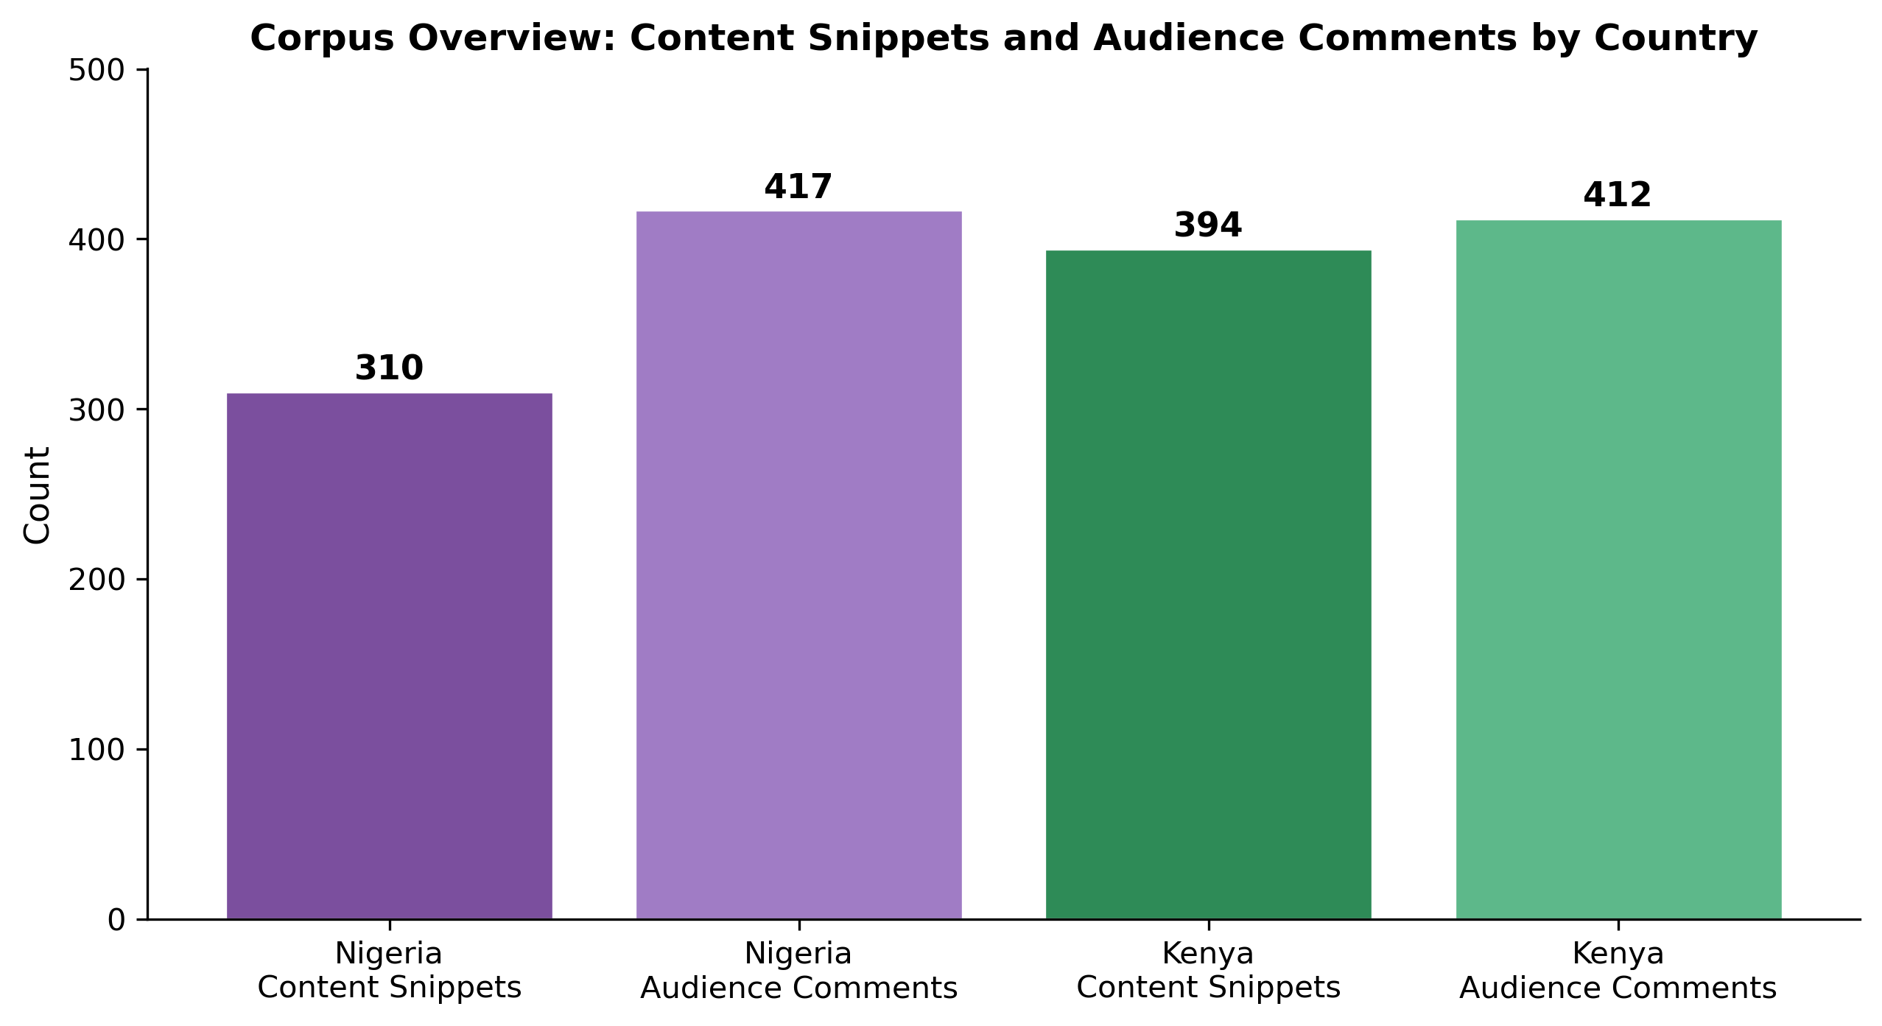
Figure 1. Corpus overview: content snippets and audience comments by country

2. Data and Sample
Nigeria's audience sample (417 comments) covers four creators: Agba John Doe (161 comments, X/Twitter), Banky Wellington (110 comments, YouTube), Deyemi Okanlawon (80 comments, X/Twitter), and Shola (66 comments, X/Twitter). The sample is heavily weighted toward X/Twitter (73.6%) relative to YouTube (26.4%), reflecting the platform distribution of sampled Nigerian creators. Only one Nigerian creator (Banky Wellington) generated a YouTube comment sample in this phase.
Kenya's audience sample (412 comments) covers four creators: Eric/Amerix (140 comments, X/Twitter, source post: a claim that women cannot love men), Eddy Kimani (110 comments, TikTok, source post: a reflection on men's societal roles), Onyango Otieno/Rixpoet (92 comments, YouTube, source: a personal testimony about his father suppressing his voice), and Andrew Kibe (70 comments, X/Twitter, source: a post implying men should not be satisfied with monogamy). The Kenya sample is more platform-diverse than Nigeria's, spanning X/Twitter (51.0%), TikTok (26.7%), and YouTube (22.3%).

Data Sources. This report uses the final complete audience-comment datasets for the current project phase: Nigeria Audience Analysis Final (https://docs.google.com/spreadsheets/d/1BaWOP85kqPy6Mcc7otD8ChrvDwXGR8hf_FY1Vv-qgpk/edit?usp=drive_link) and Kenya Audience Analysis Final / Comments (https://docs.google.com/spreadsheets/d/1Wk4j1G03XDjbUaPr6hBLjJghOz1f_-AYN16QP1GCt-M/edit?gid=526884618#gid=526884618). The companion content report uses the corresponding final creator-content datasets. All counts reported here are based on the final complete datasets, not intermediate exports, partial samples, or stale coder files.

Table 1. Nigeria Audience Sample Overview
Creator | Platform | Orientation | Comments | % of Nigeria Sample
Agba John Doe | X/Twitter | Regressive | 161 | 38.6%
Banky Wellington | YouTube | Progressive | 110 | 26.4%
Deyemi Okanlawon | X/Twitter | Progressive | 80 | 19.2%
Shola | X/Twitter | Regressive | 66 | 15.8%
TOTAL | YT: 110 / TW: 307 |  | 417 | YouTube 26.4% / X/Twitter 73.6%
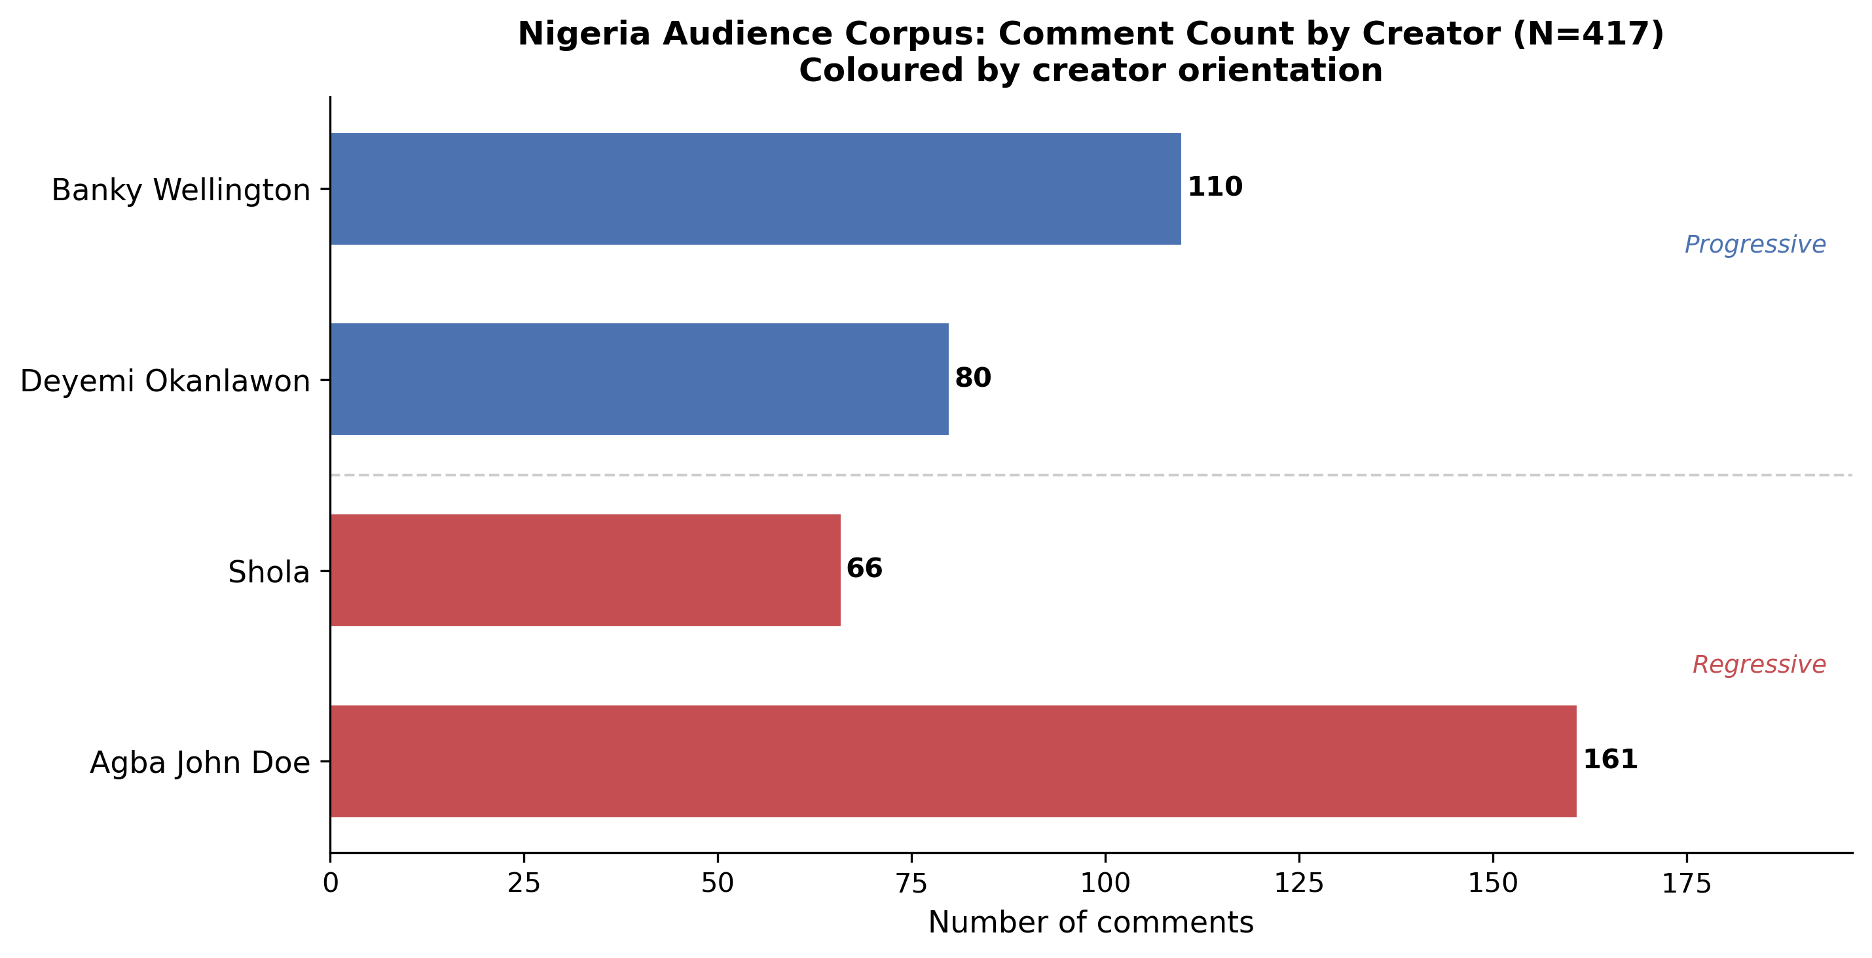
Figure 2. Nigeria audience corpus (the full body of content or text analyzed): comment count by creator and content orientation.

Table 2. Kenya Audience Sample Overview
Creator | Platform | Orientation | Comments | Source Post Theme
Eric/Amerix | X/Twitter | Regressive | 140 | "A woman can't love a man"
Eddy Kimani | TikTok | Progressive | 110 | "Men are not missing, they are evolving"
Onyango Otieno (Rixpoet) | YouTube | Progressive | 92 | "My voice was beaten out of me by my father"
Andrew Kibe | X/Twitter | Regressive | 70 | "I wonder how some men are satisfied with just one woman"
TOTAL | TW: 210 / TikTok: 110 / YT: 92 |  | 412 | X/Twitter 51.0% / TikTok 26.7% / YouTube 22.3%
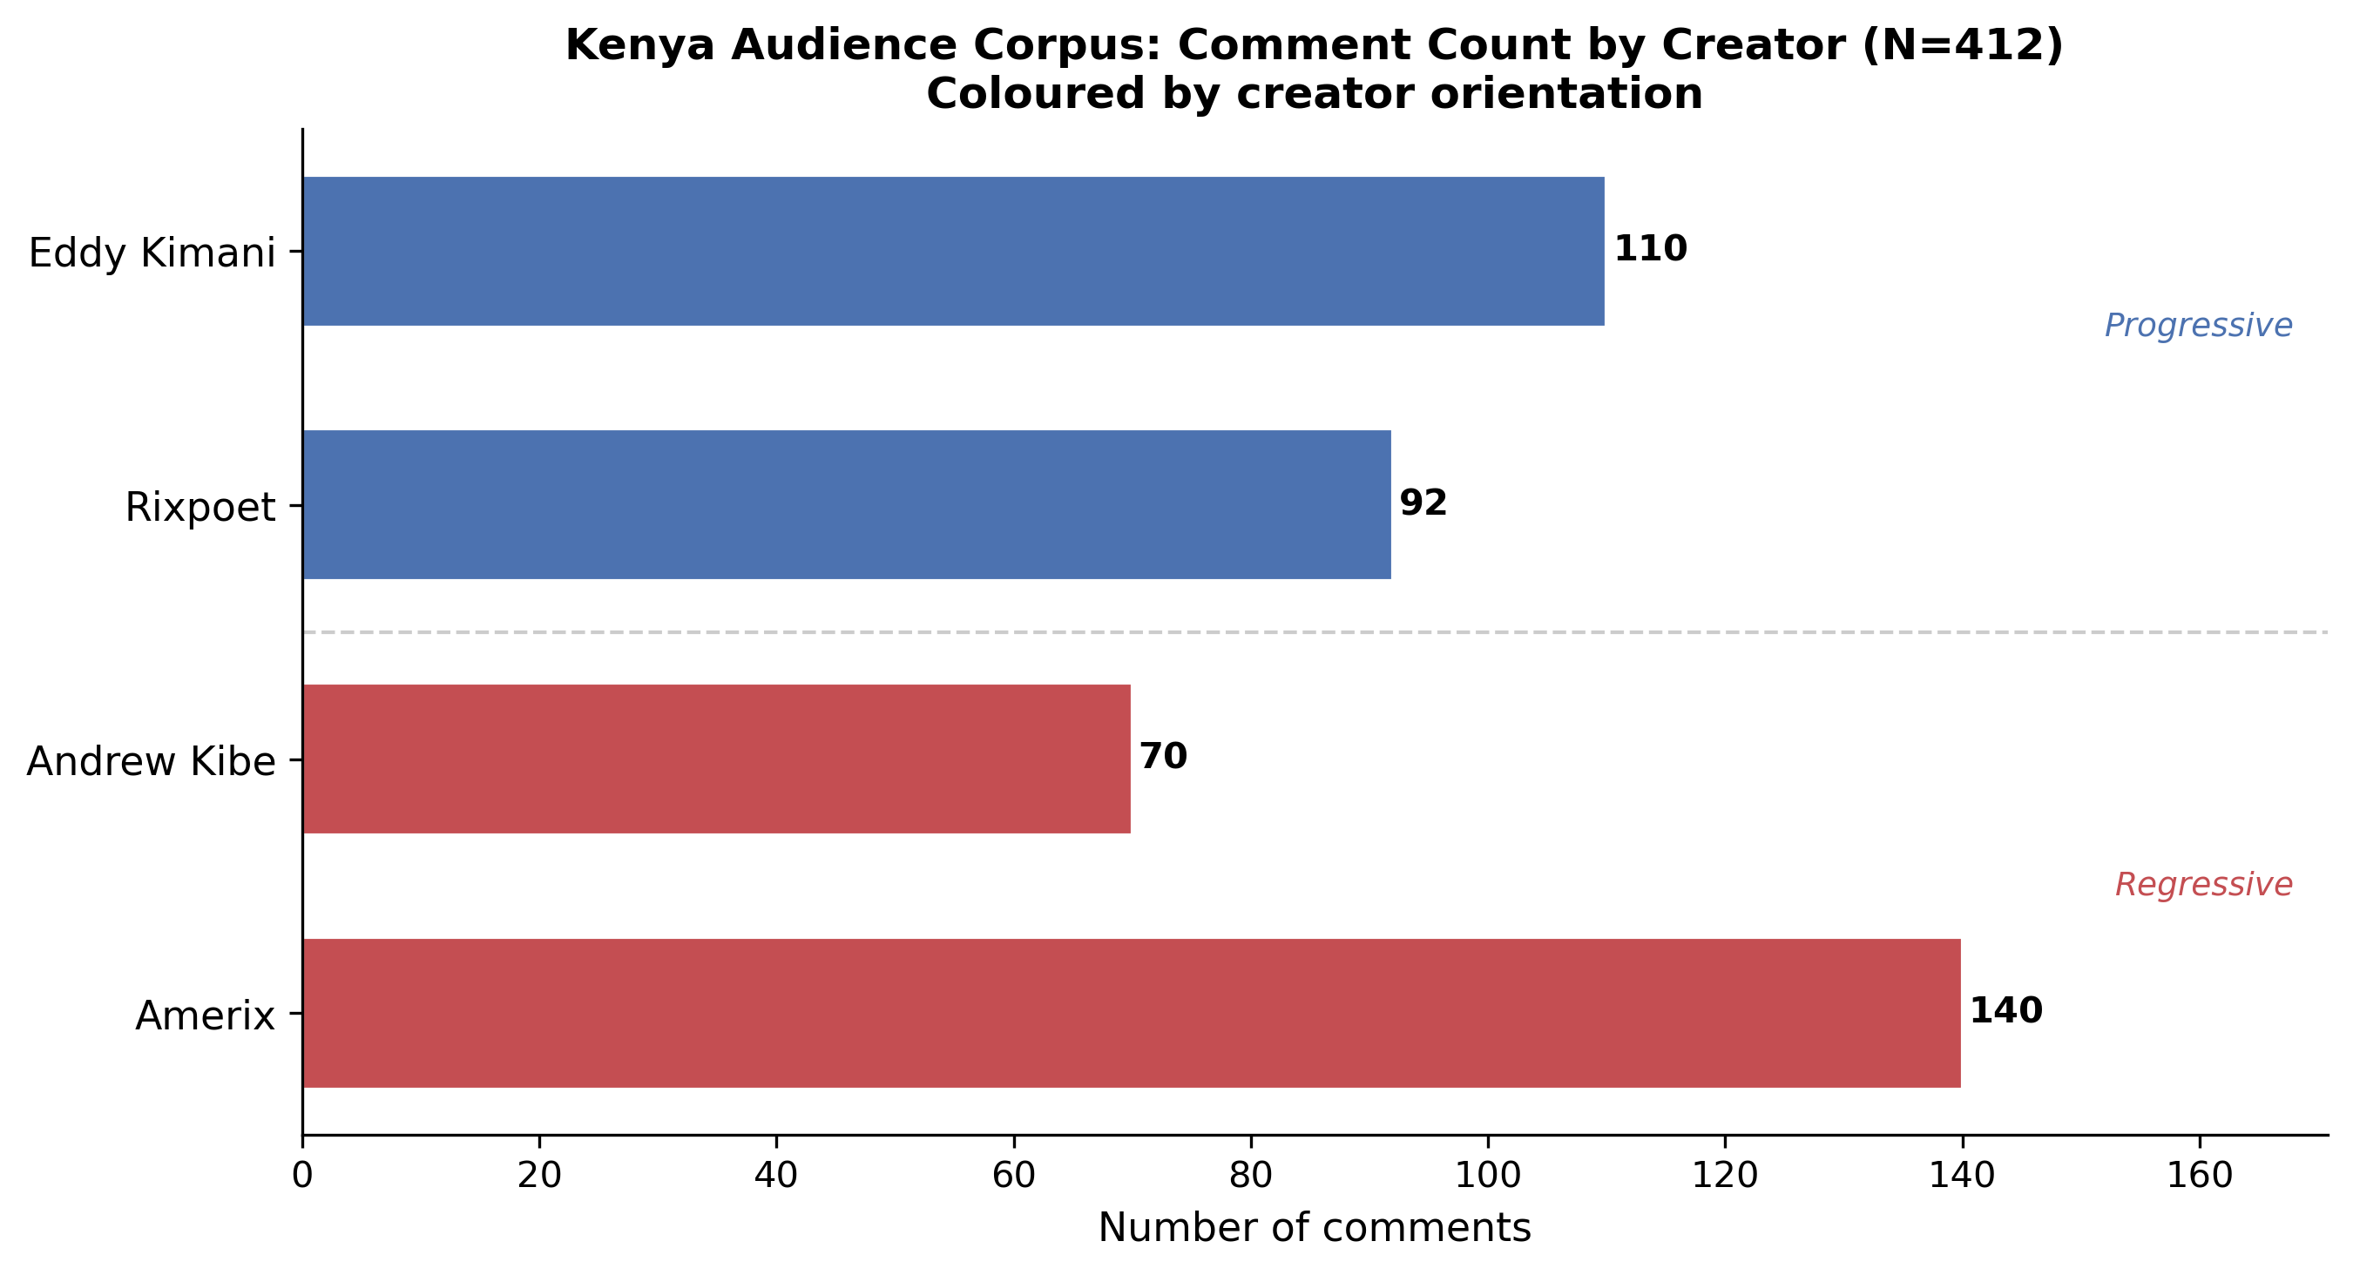
Figure 3. Kenya audience corpus: comment count by creator and content orientation.

3. Analytical Approach
Audience comments present distinct methodological challenges relative to creator content. Creator content is, in most cases, authored by a single individual, delivered in a coherent format, and organized around a discernible communicative purpose. Audience comments are fragmentary, multivoiced, and often addressed not only to the creator but to each other. They span a wide range of registers — from sustained argumentation to single-word endorsement — and they are shaped by the platform affordances (character limits, threading, reply functionality) of the specific digital environment in which they appear.
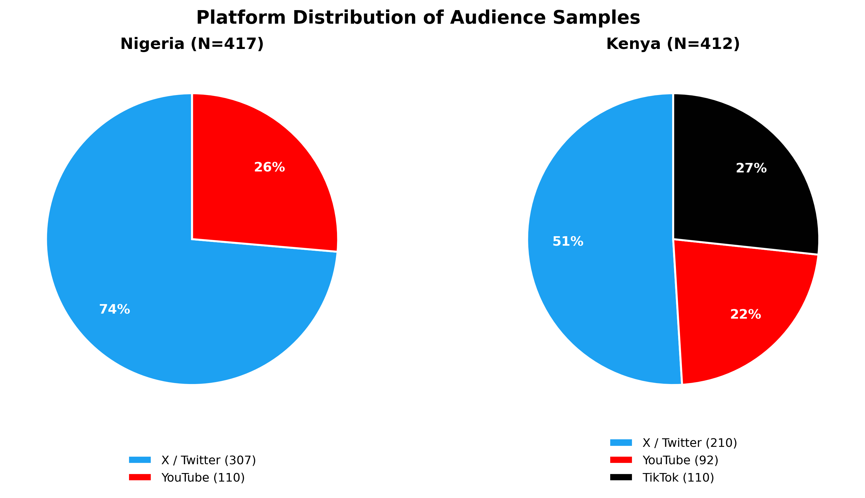
Figure 4. Platform distribution of audience samples — Nigeria (left) and Kenya (right).
This analysis treats comment sections as discourse fields: structured but dynamic spaces in which ideological positions are articulated, challenged, modified, and consolidated. Rather than coding individual comments for the presence or absence of pre-specified variables, the exploratory approach identifies recurring patterns of engagement — what we call audience themes — that characterize the comment sections of different creators. These themes describe not only what audiences say but how they say it: the rhetorical moves, social performances, and community-forming practices that characterize specific audience formations.
The decision to analyze raw comment text without structured question-by-question coding is analytically appropriate for this exploratory phase for the same reasons that apply to the content analysis: it allows the data to surface patterns that structured coding might miss, and it produces hypotheses about audience dynamics that can inform the human coding instrument. The findings reported here are interpretive, not statistically representative, and should be read as contributions to hypothesis generation rather than as confirmed results.
Three complementary analytical approaches are applied across this report:
Framing analysis examines how issues are packaged and presented to audiences — for example, whether male dissatisfaction is framed as a social injustice, a self-improvement challenge, or a woman’s fault. Framing shapes which solutions seem natural and which groups are cast as responsible. This approach is widely used in computational social science to study how narratives and messages influence public attitudes (Saveleva et al., 2024).
Argument mining identifies the claims being made, the reasoning used to support them, and the patterns of justification employed by creators and audiences. Rather than simply noting that a creator expresses a view, argument mining asks: what evidence or logic is offered? Who is blamed? What conclusion is implied? This approach is used to understand how influencers and their audiences justify gender norms (Moens et al., 2019).
Misogyny and sexism detection identifies gender-based harmful content: language that demeans, blames, or instrumentalises women as a category. This is distinct from general hostility detection and has its own established methods and benchmark datasets in the research community (Fersini et al., 2021). In this report it is applied as an interpretive lens — the analyst identifies and flags content that meets the criteria for hostile or benevolent sexism (see Glick & Fiske, 1996).
References for this section: Saveleva et al. (2024). Framing analysis. ACL Anthology. https://aclanthology.org/2024.acl-long.822/ — Moens et al. (2019). Argument mining. Computational Linguistics, 45(4). https://aclanthology.org/J19-4006/ — Fersini et al. (2021). Misogyny/sexism detection. WOAH Workshop. https://aclanthology.org/2021.woah-1.3/

4. Nigeria Audience Findings

4.1 Overview
Nigeria's 417 audience comments are distributed across four creators whose content spans both progressive and regressive orientations. The largest comment set (Agba John Doe, n=161) responds to regressive content; the second largest (Banky Wellington, n=110) responds to progressive content. This distribution, which is partly a function of platform popularity, creates an analytical environment in which the most voluminous audience discourse is generated in response to the most ideologically charged content. The regressive creators' comment sections (Agba + Shola: n=227) slightly outnumber the progressive (Banky + Deyemi: n=190), mirroring the corpus-level balance of the Nigerian content sample.
Reading across all four Nigerian comment sets reveals a comment culture that is markedly argumentative. Unlike some of the Kenyan comment sections — particularly Rixpoet's YouTube thread, which tends toward emotional disclosure — Nigerian audiences on X/Twitter in particular engage in genuine back-and-forth ideological negotiation. This is partly a platform effect: X/Twitter's threading functionality affords extended debate, and its culture rewards quick, assertive counter-argument. But it also reflects the specific social stakes of the gender ideology questions being debated, which are evidently experienced as urgent by Nigerian social media users.

4.2 Audience Responses to Regressive Content

Agba John Doe: Contested Ground on Marital Fidelity
Agba John Doe's most productive comment thread in the dataset arises from a post implying that women should remain in marriages where husbands are unfaithful — the suggestion being that leaving exposes women to greater precarity. This is a position that draws audience response across a wide ideological spectrum, producing what is analytically one of the most interesting threads in the Nigerian sample.
One cluster of commenters affirms women's autonomous agency:
“As a wife, if your husband is cheating on you, it is YOUR OWN DECISION to make whether to continue with him or leave. If you decide to stay, let it be by YOUR OWN decision.” — Nigerian audience commenter
“Dear women, don't listen to this... if you're married to a cheating man and your mental health can't take it, please leave. Marriage is not a do or die affair.” — Nigerian audience commenter
These comments assert individual autonomy and mental health as legitimate grounds for leaving a marriage. They are responding directly to what they perceive as coercive advice, and they frame their counter-advice explicitly as corrective — addressing other women in the audience rather than engaging Agba directly. This is a significant discursive (relating to how language shapes social meaning and power) move: rather than arguing with the creator, progressive-leaning commenters form a counter-public within the comment section, addressing each other and bystanders over the creator's head.
A second cluster, however, takes a more ambivalent position — acknowledging the risks of leaving while resisting any simple endorsement of staying:
“Most divorced women of African descent end up being passed around like footballs while the man ends up in a stable relationship/marriage. Don't leave your husband for the streets, sisters.” — Nigerian audience commenter
This comment is analytically complex. It neither endorses Agba's position (which implies women should stay) nor the counter-position (which asserts the right to leave). Instead, it offers a third frame: pragmatic risk assessment grounded in an observed pattern of gendered inequality in the post-divorce market. The “passed around like footballs” metaphor invokes the same objectifying logic that structures regressive masculinity content, but deploys it as a warning rather than a prescription — and deploys it in solidarity with women rather than against them. This ambivalence, which cannot be neatly categorized as either progressive or regressive, is a characteristic feature of ideologically liminal comment content.
The sheer size of Agba's comment sample (161 comments from a single creator) suggests an audience formation that is not primarily passive. Agba's “Agbafian” community identity means that a significant portion of his commenters are likely invested participants who follow him specifically because they find his worldview compelling. The presence of counter-commentary within this space is thus notable: it suggests that even strongly ideologized creator comment sections are not hermetically sealed echo chambers.

Shola: Hypergamy as Shared Identity
Shola's 66-comment sample shows a different audience dynamic: one in which ideological mirroring is more dominant and counter-commentary is less prominent. Shola's audience on X/Twitter appears to function as a community of shared conviction rather than a debate forum, and the comments reflect this.
“Men are the prize. These girls are just in their era and they feel like all men are after them — until they can't even find one.” — Shola audience commenter
“Welcome to the era where a man's last name is the ultimate asset, and women are lining up like investors.” — Shola audience commenter
“Remember the saying 50 women for one man, we going towards it.” — Shola audience commenter
These comments do not engage with any specific argument Shola has made; they amplify and extend the ideological frame. The "men are the prize" formulation, the investment metaphor, and the 50-women ratio are all elements of the sexual marketplace ideology that structures Shola's content. What the audience is doing here is not analyzing or evaluating; it is performing membership — demonstrating fluency in the shared discourse of the community.
The investment metaphor is worth examining closely. "A man's last name is the ultimate asset, and women are lining up like investors" reframes marriage not as mutual commitment but as a financial transaction in which women compete for access to male capital. This is ambivalent sexism in its benevolent mode: it appears to elevate women (as intelligent investors) while substantively objectifying them (as actors whose worth is instrumental, defined by the asset they seek). The fact that this framing is offered by an audience member rather than the creator illustrates how ideological reproduction in comment sections can extend and intensify the creator's framework.

4.3 Audience Responses to Progressive Content

Banky Wellington: Cross-Gender Engagement and Appreciative Reception
Banky Wellington's YouTube comment section is the most formally distinct in the Nigerian sample — both because YouTube affords longer-form comments and because the MENtality podcast format explicitly invites thoughtful engagement. The result is a comment section that reads more like a seminar discussion than a debate, with audience members offering substantive reflections rather than brief assertions.
“I want to thank you guys for bringing up this podcast as it helps throw more light on modern masculinity and not the toxic form seen everywhere on social media. Men don't talk about these things a lot.” — Banky Wellington audience commenter
This comment performs several moves simultaneously: it thanks the creators (establishing a relationship of gratitude and appreciation), characterizes the podcast as distinctive relative to the ambient discourse ("not the toxic form seen everywhere on social media"), and affirms the social function of the content (creating space for what men otherwise cannot say). The comment positions the audience member as part of a progressive-masculinity-aware community that recognizes the rarity and value of the content.
Several YouTube commenters engage with the substantive gendered inequality of recognition:
“One thing I've noticed is that when a man fulfills his responsibilities, it's seen as a normal thing. But when a woman does, it's often described as her 'helping' or 'taking care of your responsibilities.'” — Banky Wellington audience commenter
This observation — that the same action is coded differently depending on the gender of the actor — reflects a sophisticated awareness of the gendered dynamics of recognition and labor. It does not come from the creator's content directly; it is the audience member's own analytical contribution. This is an example of what the audience adds to progressive masculinity discourse: their own experience and observation, not just the creator's framework.
Strikingly, several commenters explicitly identify as feminist, a move that would be unusual in the comment sections of regressive creators:
“As a feminist, one thing I have learnt is [not] generalization because I know that there are men out there who are striving to do better.” — Banky Wellington audience commenter
This comment, from a self-identified feminist, performs a form of cross-ideological appreciation: it acknowledges individual male effort within a structural feminist framework, without abandoning either. The progressive masculinity podcast space, in this case, functions as a meeting ground for audiences who might otherwise not encounter each other's perspectives.
Not all Wellington audience engagement is appreciative, however. One commenter identifies a gap in the content:
“How about you talk about the mentality of men that grew up without a father.” — Banky Wellington audience commenter
This request points toward a specific male experience — fatherlessness and its psychological effects — that the podcast has not addressed. It is an example of audience co-production: the comment section as a site where audiences actively shape the content agenda, suggesting topics that feel urgent and unaddressed. The fatherlessness question is particularly significant in a context where men's mental health discourse often does and should engage the intergenerational transmission of behavior patterns.

Deyemi Okanlawon: The Rape/False Accusations Thread
Deyemi Okanlawon's 80-comment sample is most analytically interesting in the comment threads generated by his engagement with rape accusation discourse. Okanlawon's tweets on the topic engage both victim testimony and the question of false accusations, and this dual engagement produces a comment section that is divided along clear ideological lines.
One cluster asserts an unequivocal anti-rape position:
“YES!!! There is absolutely no excuse and no room for debate when it comes to the safety and bodily autonomy of women.” — Deyemi Okanlawon audience commenter
A second cluster introduces the false-accusation counter-frame:
“You can't talk about rape accusations without also talking about false rape accusations.” — Deyemi audience commenter
A third then counters the counter-frame:
“Saying talk about false accusations under every rape case is crazy.” — Deyemi audience commenter
This three-way dynamic is a particularly clear example of what might be called countermovement threading: the comment section of a progressive creator becomes a site where regressive positions are articulated, met with counter-argument, and pushed back against again. The practical effect is a visible representation of ideological conflict rather than the echo-chamber dynamics more characteristic of regressive creator comment sections. Progressive creator comment sections, at least in this Nigerian sample, appear more likely to host genuine ideological contest.
The specific content of the false-accusation interjection is worthy of attention. The claim that "you can't talk about rape accusations without also talking about false rape accusations" is a well-documented rhetorical strategy in anti-feminist discourse: it introduces a counter-concern (false accusations) as a required companion to any discussion of sexual violence, effectively diluting or deflecting attention from the primary phenomenon. The audience's pushback ("that's crazy") demonstrates that this strategy is recognized and contestable, at least within the comment community that Okanlawon's content attracts.

4.4 Cross-Cutting Audience Dynamics in Nigeria
Across Nigeria's four creator comment sections, several patterns emerge that cut across the progressive/regressive divide.
First, the comment sections of regressive creators tend toward ideological consolidation, while the comment sections of progressive creators tend toward ideological contest. This asymmetry may reflect self-selection: audiences who choose to comment on regressive content are more likely to already share the creator's worldview, while audiences who comment on progressive content include a more heterogeneous mix of perspectives. It may also reflect platform dynamics: X/Twitter's threading and reply culture enables extended debate in ways that are less characteristic of less contested content.
Second, even the most ideologically homogeneous comment sections contain outliers. The presence of counter-commentary in Agba's thread — a creator with a highly identified follower community — suggests that ideological enclosure is never complete in public comment sections. This finding is significant for the research project: it implies that progressive voices are present even in regressive creator spaces, which has implications for modeling the exposure effects of creator content.
Third, the distinction between engaging the creator and engaging other commenters is analytically significant. Progressive-leaning commenters in regressive creator spaces often address other women or other readers rather than the creator directly, forming what functions as a counter-public within the comment section. This discursive strategy — speaking past the creator to a co-present audience — is a form of ideological resistance that operates below the level of direct confrontation.

5. Kenya Audience Findings

5.1 Overview
Kenya's 412 audience comments span four creators across three platforms: X/Twitter (210 comments), TikTok (110 comments), and YouTube (92 comments). This platform diversity is more pronounced than Nigeria's, and it shapes the character of the audience discourse in notable ways. X/Twitter comments (Amerix, Kibe) tend toward assertive, compact ideological statements; TikTok comments (Eddy Kimani) tend toward community-building and emotional affirmation; YouTube comments (Rixpoet) tend toward extended personal narrative and therapeutic disclosure. These platform differences are not absolute — there is overlap — but they constitute a consistent background pattern.

Kenya's audience sample also shows more visible cross-gender engagement than Nigeria's. This is most visible in Rixpoet's YouTube comment section, where women commenters disclose personal experiences directly related to the creator's testimony. It is also visible, in a more complex register, in Kibe's X/Twitter comments, where the monogamy/polygamy debate draws both male endorsers and female dissenters. Kenya's audience discourse is, on the evidence of this sample, somewhat more gender-integrated than Nigeria's.

5.2 Audience Responses to Regressive Content

Eric/Amerix: Ideological Mirroring and the Ontology of Love
Amerix's source post — the claim that women are constitutionally incapable of loving men — generates a comment section that is among the most ideologically coherent in the combined corpus. The majority of comments either directly affirm Amerix's claim or extend it through complementary argumentation.
“While women fantasize about relationships, men fantasize about greatness... A man's desire for greatness is so strong that he will attempt to experience it through someone else.” — Amerix audience commenter
“@amerix The only love that is unconditional is the love for yourself. The rest, you have to do something to be loved.” — Amerix audience commenter
“Love is a fallacy. It's women who purport to love men but in reality it's because of what men can provide. #Changeorperish” — Amerix audience commenter
These comments perform what we have called ideological mirroring: they reproduce and extend the creator's ontological (relating to fundamental claims about the nature of reality or identity) claim (women cannot love men) with additional supporting arguments (men seek greatness; all love is transactional). The hashtag #Changeorperish is a particularly interesting element — it imports an explicitly mobilizational framing into what is ostensibly a descriptive claim about female psychology. The audience, in other words, is not merely agreeing with Amerix; it is participating in the construction of a collective ideological position.
Some commenters, however, introduce a dissenting note:
“Love is definitely a two-way street. True love thrives on mutual respect, trust, and understanding.” — Amerix audience commenter
“A woman must obey, submit, and respect her man to be loved.” — Amerix audience commenter
The first of these is a straightforward counter to Amerix's claim, asserting the mutuality of love. The second is more ambivalent — it accepts a hierarchical love model but acknowledges that women do experience love, even if conditionally. These minority positions in the comment section demonstrate that Amerix's audience is not entirely homogeneous, even if the dominant mode is affirmation.
The sheer volume of Amerix's sample (140 comments from a single post) suggests an audience formation with high engagement rates and a core of highly committed followers who respond quickly and at length to creator content. The consistent deployment of specialized vocabulary — "hypergamy," "simp," "soy men" — across both creator content and comment sections indicates that this community has developed a shared lexicon that functions as an ideological identity marker.

Andrew Kibe: The Monogamy Debate and Female Objectification
Andrew Kibe's 70 comments, drawn from a post questioning why men would be satisfied with monogamy, generate a more contested discussion than Amerix's — with meaningful pushback from audience members who reject the objectification logic embedded in Kibe's original post.
“True love isn't about variety, it's about loyalty. A man who truly loves invests in one heart.” — Kibe audience commenter
“Comparing women to cars is already where the logic falls apart. Love isn't about collecting options, it's about choosing one person fully.” — Kibe audience commenter
These counter-comments are notable both for what they assert (loyalty, choice, investment) and for how they argue. The second comment — identifying the cars-to-women comparison as the point at which "the logic falls apart" — engages Kibe's analogy directly rather than simply stating a contrary position. This is a more sophisticated form of counter-argument than simple assertion of the opposite view, and it suggests an audience member who has thought about the structure of the claim being made.
At the same time, Kibe's position also attracts support:
“Some men just have options and the capacity to handle them. If you love cars, you don't park one in the garage for life... The problem isn't wanting more, it's lying about it.” — Kibe audience commenter
This comment accepts the cars-to-women comparison (rather than contesting it) and shifts the moral register: the problem is not polygamous desire but dishonesty about it. This is a position that accommodates the objectifying logic of Kibe's framework while adding a quasi-ethical principle (be honest about what you want). It is ideologically more sophisticated than simple mirroring and represents a form of creative extension — the audience member taking the creator's position and developing it in a somewhat original direction.
The presence of genuine debate in Kibe's comment section, unlike Amerix's, may reflect the specific post context and the monogamy/polygamy topic, which invites stronger cross-ideological response. Where Amerix's post frames female psychology as an ontological fact, Kibe's post on monogamy is a normative claim that a wider range of commenters feel equipped to contest on their own terms.

5.3 Audience Responses to Progressive Content

Rixpoet: Therapeutic Resonance and Autobiographical Disclosure
Rixpoet's 92 YouTube comments, drawn from a video in which he testifies about his father beating his voice out of him, constitute the most emotionally intense audience corpus in the combined dataset. The dominant mode of engagement is not argument or mirroring but personal disclosure: audience members responding to Rixpoet's testimony with testimony of their own.
“Man this story just stirred some emotions in me. I feel like you just told my whole story.” — Rixpoet audience commenter
“This is a refreshing interview. Happy to see men stepping out of toxic societal norms and becoming emotionally healthy.” — Rixpoet audience commenter
The first comment — "I feel like you just told my whole story" — is the paradigmatic instance of what we are calling therapeutic resonance: the audience member's recognition of their own experience in the creator's narrative. This is a different relationship to content than endorsement, debate, or even appreciation. It is identification: the dissolution of the boundary between witnessing and being witnessed. Rixpoet's willingness to narrate his own vulnerability activates a corresponding willingness in the audience.
The second comment performs a different but related move: it celebrates Rixpoet's act not as personal catharsis but as social contribution — "stepping out of toxic societal norms and becoming emotionally healthy." The audience member here is not just responding to the video; they are articulating a theory of what the video accomplishes, and positioning it within a broader social project of changing male norms.
Rixpoet's comment section is also distinctive in the degree to which women's voices are present and engaged:
“Thanks for sharing. My husband was abusive but later on I tried to check on his background. I found out that was what his father used to be. The pattern was repeating itself.” — Rixpoet audience commenter
This comment, from a woman describing her own experience of male intimate partner violence, connects directly to Rixpoet's content on the intergenerational transmission of trauma. The woman is not contesting the creator or debating with other commenters; she is contributing evidence — personal testimony — that corroborates the analytical frame Rixpoet has offered. The result is a comment section in which creator testimony and audience testimony mutually support and extend each other, creating a community of shared experience that spans both the speaker's position and the listener's.
This dynamic — creator vulnerability activating audience vulnerability — is analytically significant for understanding the mechanism by which progressive masculinity discourse operates. It is not primarily persuasion (convincing people to hold different views) but witnessing (creating conditions in which hidden experiences can be named and shared). This suggests that the most important effects of progressive masculinity content may not be measurable through attitude surveys but through qualitative attention to the social practices of disclosure and recognition it enables.

Eddy Kimani: Performance Culture and Gendered Resource Grievance
Eddy Kimani's 110 TikTok comments respond to a post framing men as "evolving" rather than "missing" — a reframing of male absence as purposeful transformation. The comment section is the most platform-distinct in the sample: TikTok's culture rewards brevity, affirming energy, and community identification, and these features shape the audience response.
“It's about time. The performance culture is draining. It's time to stay grounded and operate in clarity.” — Eddy Kimani audience commenter
The "performance culture" formulation — a commenter's own coinage, not drawn from Kimani's content directly — names something significant: the social demand that men perform a stable, competent, unfragmented masculinity regardless of their internal experience. This is what Kimani's stage testimony, with its narration of failure and eviction, is implicitly contesting. The audience member's comment shows that at least some of Kimani's audience shares this analysis and has vocabulary for it.
A more complex dynamic appears in comments that surface gendered resource grievance:
“Most of the women you saw are my sister that our Dad took to college and university, I was left out after high school.” — Eddy Kimani audience commenter
This comment introduces a legitimate structural complaint — a son who was not given the educational investment that daughters received — within the context of a progressive masculinity video. The grievance is real: unequal investment in daughters over sons is a documented pattern in some African family contexts where daughters are seen as more reliably supportive of parents in later life, or where daughters are given priority as compensation for their disadvantaged position. But within the frame of Kimani's content, which is oriented toward men's transformation and emotional growth, this grievance can be read in two ways: as a legitimate acknowledgment of male deprivation that progressive discourse should engage, or as a resentment that, if cultivated, feeds into regressive masculinity's tendency to position men as victims of female preference.
Another comment engages the structural paradox of masculine self-improvement:
“Walking away from systems set up by the same men is ironical... but maybe it is well needed.” — Eddy Kimani audience commenter
This observation — that men who critique hegemonic masculinity are critiquing systems they themselves have benefited from or perpetuated — is a structurally sophisticated point that goes beyond the typical audience comment. It names the contradictions of progressive masculinity discourse without resolving them, and it does so with the slightly distancing qualifier "ironical" that acknowledges complexity without committing to either endorsement or rejection. These kinds of liminal, structurally aware comments are among the most analytically rich material in the dataset.

5.4 Cross-Cutting Audience Dynamics in Kenya
Kenya's audience findings reveal several patterns that cut across creator orientation and platform.
First, the therapeutic resonance dynamic — in which creator disclosure activates audience disclosure — appears more visible in the sampled Kenyan progressive creator comment sections than in the sampled Nigerian comment sections, likely reflecting platform, topic, and creator-selection differences.
Second, the presence of women commenters is more prominent and more substantive in Kenya's progressive comment sections than in Nigeria's. Women in Rixpoet's comment section contribute personal testimony about abusive relationships; women in Kibe's comment section push back against polygamy advocacy. This cross-gender engagement is not absent from Nigeria’s sample — women are present in Agba’s threads — but it appears more visible and sustained in the sampled Kenyan content, a pattern that may partly reflect creator-selection differences between the two countries.
Third, the ideological contest in Kenya's regressive creator comment sections is structurally different from Nigeria's. Amerix's comment section shows predominantly mirroring, with isolated dissent. Kibe's comment section shows a more genuine debate. This difference may reflect the specific posts sampled: the monogamy/polygamy question is more obviously debatable (it has normative ambiguity in Kenyan society) than Amerix's ontological claim about female love (which is more unusual and thus more clearly contestable only from outside its framework). It illustrates that the nature of the triggering post shapes the structure of the audience response.

6. Cross-National Comparative Audience Analysis
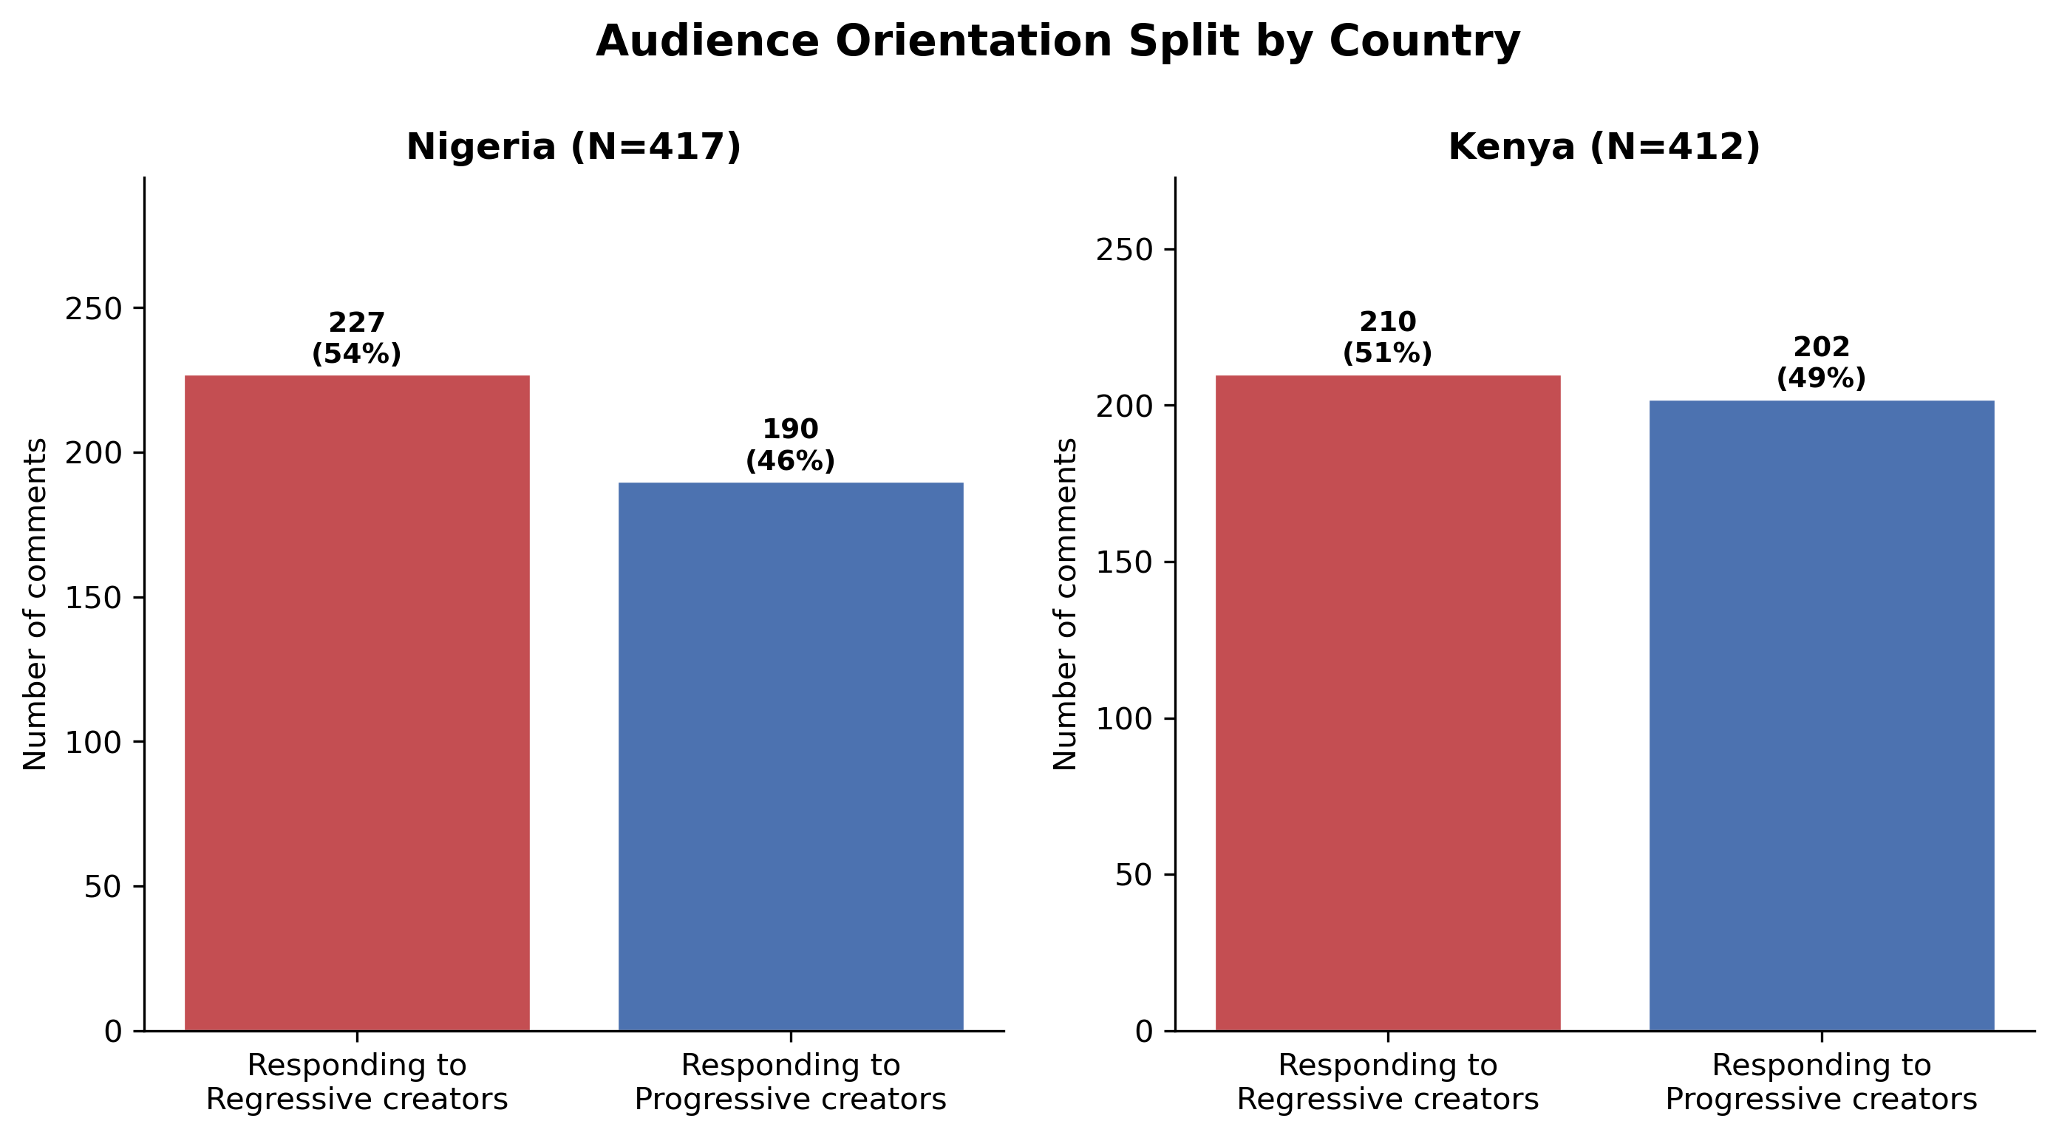
Figure 5. Audience orientation split by country: comments responding to progressive vs. regressive creators in Nigeria and Kenya.
Comparing the Nigerian and Kenyan audience datasets reveals several patterns of cross-national convergence and divergence.
The most consistent cross-national pattern is ideological mirroring in regressive creator comment sections: audiences of regressive creators in both countries tend to reproduce and extend the creator's ideological framework rather than contest it. The Shola and Amerix comment sections both show this pattern clearly, despite their platform difference. This convergence suggests that the self-selection dynamics of creator fandom — whereby audiences seek out content that validates existing beliefs — operate similarly in Nigeria and Kenya, and perhaps more broadly.
A consistent cross-national divergence is the character of progressive creator comment sections. Nigerian progressive creator audiences engage in argument; Kenyan progressive creator audiences engage in therapeutic disclosure. This may reflect differences in the specific content sampled — Wellington's and Okanlawon's podcast/Twitter content invites intellectual engagement, while Rixpoet's workshop testimony invites emotional resonance. But it may also reflect broader differences in how emotional disclosure is culturally available as a public practice in the two countries' digital spaces. Kenyan progressive masculinity content appears to create conditions for emotional community in ways that Nigerian progressive content does not, at least in this sample.
Cross-gender audience engagement appears more visible in the sampled Kenyan comment sections than in the sampled Nigerian comment sections. In both countries, progressive creator comment sections attract more gender-diverse audiences than regressive creator sections. In the sampled Kenyan data, this diversity is more actively expressed: women contribute sustained substantive comments, not just brief affirmations or objections. This pattern is analytically suggestive for modeling the potential reach of progressive masculinity content across gender lines, though it may partly reflect differences in creator selection and platform between the two countries.
A distinctively Nigerian pattern — the rape/false-accusations deflection dynamic in Okanlawon's comment thread — does not appear prominently in the sampled Kenyan audience data reviewed here. While gender-based violence is engaged in Kenya's progressive content (Philip Karanja, Rixpoet), the comment sections in Kenya do not show the same countermovement threading dynamic that characterizes Nigeria's. This may reflect sample differences (the specific posts generating the comment sets) or genuine contextual differences in how the online gender politics of SGBV operates in the two countries.
Finally, the gendered resource grievance surfaced in Eddy Kimani's TikTok comment section does not appear prominently in the sampled Nigerian audience data reviewed here. The specific complaint — of having been educationally disinvested relative to sisters — may be more salient in the Kenyan context, or may simply reflect the specific audience that Kimani's content attracts. But the dynamic it represents — legitimate structural grievance co-existing with progressive content consumption — is one the research team should attend to in subsequent phases, as it marks a potential site of ideological migration between progressive and regressive audiences.

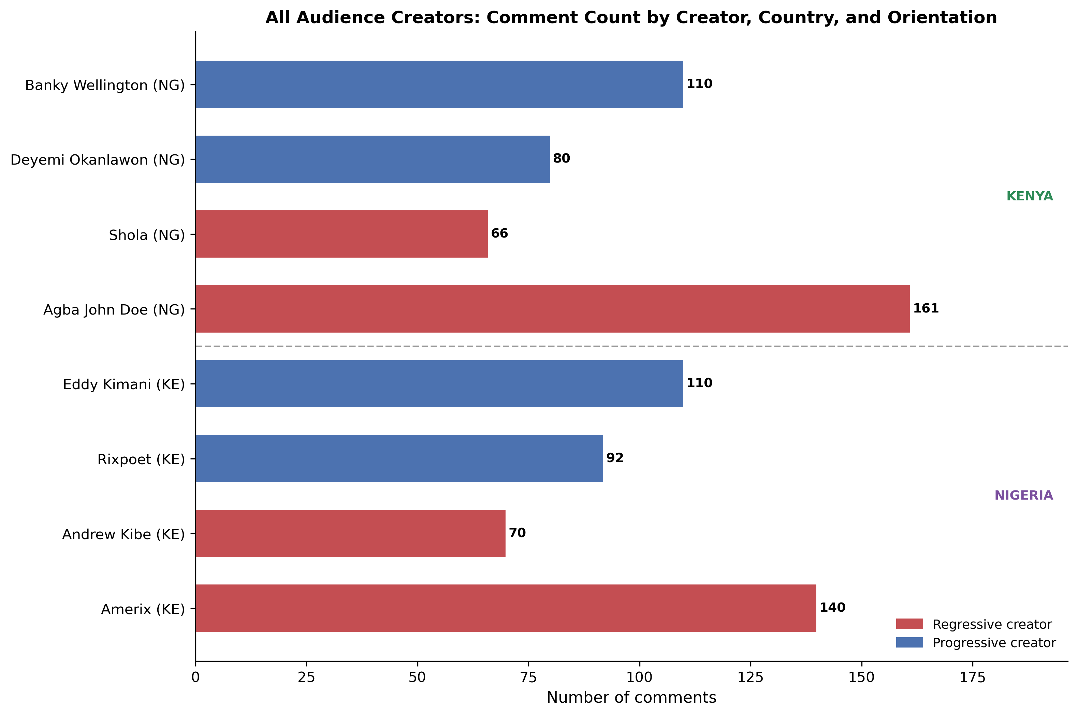
Figure 6. All audience creators: comment count by creator, country, and orientation. Kenya appears above the divider; Nigeria appears below.

7. Discussion
The audience analysis yields several substantive findings that complement and extend the content analysis reported separately.
First, comment sections are not simple reception sites. They are production sites — spaces in which ideological positions are not only expressed but collectively constructed, refined, and performed. The Shola and Amerix comment sections show audiences extending and intensifying the creator's ideology in directions that go beyond simple endorsement. The Rixpoet and Wellington comment sections show audiences contributing their own analytical and experiential material to the discourse. In neither case is the audience simply absorbing creator content.
Second, the distinction between echo-chamber dynamics and productive dissent is empirically real in this dataset, and it maps — imperfectly but consistently — onto the progressive/regressive orientation of the creator. This has implications for how the research team thinks about the normative effects of different types of content. Regressive creator content appears to generate more homogeneous audience discourse, which may intensify ideological commitment. Progressive creator content appears to generate more heterogeneous discourse, which may have different effects on different audience sub-populations — affirming progressive-leaning audiences, challenging regressive-leaning visitors, and creating community for those in between.
Third, the therapeutic resonance dynamic in Rixpoet's comment section represents a distinctive mechanism of masculinity norm change that is worth tracking in subsequent phases. If the primary mechanism is not persuasion but disclosure — the creation of conditions in which men (and women) can name and share experiences previously held in silence — then the research instruments developed for the coding phase should be sensitive to this dimension. Attitude-change measures alone will not capture the social function of therapeutic masculinity discourse.
Fourth, the presence of structurally aware, analytically sophisticated commenters in both progressive and regressive audiences — audience members who articulate theories about what is happening in the discourse, identify the structure of arguments being made, and name their own contradictions — is an analytically important finding. These commenters are not simply subjects of norm exposure; they are active interpreters of the discursive field. Their presence in comment sections suggests that the audience for masculinity content includes people with significant critical capacity, which complicates any simple model of ideological transmission from creator to audience.

Appendix: Reach Metrics for Audience Source Posts
All figures are as recorded at time of collection. “n/a” indicates the metric is not available for that platform or was not captured. Likes on the source post are distinct from engagement on individual comments sampled for analysis.

Kenya — Audience Source Post Engagement
Creator | Source Post / Video | Platform | Views / Plays | Likes | Source Post Comments / Replies
Amerix | Do not marry a modern woman | X | 281,103 | 7,781 | 213
Amerix | A woman can’t love a man… | X | 662,079 | 13,592 | 464
Andrew Kibe | I wonder how some men are satisfied with one woman | X | 160,965 | 3,512 | 154
Andrew Kibe | There is no amount of sex… that will keep a woman faithful | X | 69,716 | 1,058 | 71
Philip Karanja | Happy Women’s Day — documentary announcement | Instagram | 60,353 | 5,391 | 132
Philip Karanja | Episode 1: A Girl Dad on a Mission | YouTube | 109,704 | 2,886 | 186
Onyango Otieno | Undoing My Father’s Damage | YouTube | 50,619 | 916 | 174
Onyango Otieno | My voice was beaten out of me by my father | YouTube | 36,394 | 676 | 251
Eddy Kimani | Young man — shame not having a car at 35 | TikTok | 459,800 | n/a ³ | 2,251
Eddy Kimani | Men Are Not Missing. They Are Evolving! | TikTok | 305,400 | n/a ³ | 1,526

Nigeria — Banky Wellington: Source Video Engagement
Source Video | Platform | Views | Likes | Source Post Comments / Replies
Final Say Faith | YouTube | 1,836,128 | 73,971 | 7,200
My Story — A Journey Through Hope & Faith | YouTube | 711,135 | 10,943 | 772

Nigeria — Twitter/X Creators: Comment Pool
Source-post engagement metrics were not consistently captured for the four Nigeria Twitter/X creators. The table below shows the comment pool per creator (comment count and aggregate likes / retweets on those comments) drawn from raw audience files.
Creator | Comments Collected | Total Likes on Comments | Total RT on Comments
Agba John Doe | 756 | 13,170 | 1,967
Deyemi Okanlawon | 805 | 24,321 | 3,004
Shola | 679 | 14,095 | 2,040
Wizarab | 494 | 21,251 | 3,899
Banky Wellington (YouTube) | 12,327 | 70,803 | —

¹ Pre-2022 X/Twitter posts: view counts not publicly available.
³ TikTok does not display like counts to external viewers. Metric not available.
Reach metric note: Some platform-level metrics could not be recovered from open web sources. For older X/Twitter posts (pre-December 2022), public view counts were not surfaced on the platform at the time of posting and are not recoverable from open sources; these are marked "n/a \u00b9". TikTok like and share counts require platform or API access and were not reliably visible through open web search; these are marked "n/a \u00b3". Repost/retweet counts for YouTube posts are not applicable to the platform. Where collection-time data from raw project files differed slightly from scope documentation, raw file values have been used as the primary source. Values left blank or marked "n/a" reflect genuine data unavailability, not estimation gaps.
— YouTube values in the “Source Post Comments / Replies” column are platform-level source-video comment counts, not the number of comments sampled for analysis.

7. Reach and Engagement Patterns
Interpretive note: The findings below are descriptive, not statistical or causal. They answer the question: which narratives and topics appear attached to higher-engagement posts in this sample? They do not establish that those narratives caused higher engagement. This is consistent with the exploratory scope of this analysis.
Note on cross-platform comparability: Engagement metrics are not directly comparable across platforms. Likes and retweets on X/Twitter reflect a different virality logic than YouTube comment counts or TikTok reply counts. Figures should be read within-platform.

7.1 Nigeria
On Nigeria X/Twitter, source-post metrics were not consistently captured for every sampled post, so the safest reach read is corpus-level rather than per-post average. In the raw tweet files, Shola shows the largest aggregate engagement among the Nigeria X/Twitter creators listed here, with 280,817 likes and 51,807 retweets across 143 posts, followed by Agba John Doe with 100,501 likes and 16,072 retweets across 120 posts, Wizarab with 25,157 likes and 5,676 retweets across 100 posts, and Deyemi Okanlawon with 13,209 likes and 1,623 retweets across 135 posts. These figures suggest strong engagement around sexual-marketplace/hypergamy, provider and relationship-economics narratives, and accountability/anti-rape narratives, but they should not be interpreted as causal evidence or directly comparable to YouTube/TikTok engagement.
The highest-engaging Nigeria posts centred on hypergamy and partner selectivity (Wizarab, Shola), provider masculinity and relationship economics (Agba John Doe), and counter-narratives around male accountability and anti-rape advocacy (Deyemi Okanlawon). Short, directive, provocative posts characteristic of regressive X/Twitter content attracted the highest retweet counts, consistent with the platform’s brevity-reward structure.

7.2 Kenya
On X/Twitter, Amerix (Eric Amunga, regressive) generated the highest raw reach in the Kenya sample. His post “Stay away from vulgar women” received 14,322 likes and 3,711 retweets — the single highest-reach post across both countries. Andrew Kibe (regressive, primarily active on YouTube/podcast) was also represented on X/Twitter, with sampled posts averaging 2,285 likes and 296 retweets. Both regressive creators’ highest-performing content centred on punitive femininity framing: female speech, self-presentation, and sexuality as grounds for relational disqualification.
Progressive creators operated primarily on YouTube and TikTok. Rixpoet’s YouTube videos averaged 204 comments per video, with highest engagement on father-son trauma and toxic masculinity content — generating sustained, emotionally disclosive comment threads consistent with the therapeutic resonance dynamic identified in the audience analysis. Eddy Kimani (TikTok/YouTube) and Philip Karanja (podcast/YouTube) operated in formats where reach metrics are structurally lower but audience engagement depth differs qualitatively from X/Twitter virality.

8. Technical Notes and Limitations
This analysis is explicitly exploratory and interpretive. The findings reported are based on close reading of 829 verbatim audience comments across eight creator comment sections in two countries. No structured question-by-question coding was applied, and no statistical analysis was conducted. The claims made are grounded in specific evidence from the data, but they are hypothesis-generating rather than hypothesis-confirming.
Comment sampling decisions affect the findings substantially. The choice of which post to sample comments from — a decision that was made prior to this analysis — shapes the character of the audience discourse in ways that may or may not be representative of each creator's broader audience. Amerix's "women can't love a man" post attracts a particular type of response that may be different from the responses to other Amerix posts. This is a standard limitation of comment sampling and should be noted when interpreting the findings.
Platform differences — X/Twitter vs. YouTube vs. TikTok — produce structural differences in comment form, length, and social function that this analysis has attempted to account for but cannot fully control. Future coding instruments should include platform as a moderating variable in any analysis of audience comment characteristics.
This report covers only four creators per country. Nigeria's comment sample does not include Wizarab or Ebuka Obi-Uchendu; Kenya's does not include Philip Karanja. The content analysis (reported separately) covers all eleven creators; the audience analysis is more selective. Findings from the audience analysis should be understood as covering a subset of the overall project's creator sample, and generalizations to non-sampled creator audiences should be made with caution.
All quotations are verbatim from the original comment data, with only the minimal correction needed for clarity (e.g., punctuation). No paraphrase has been substituted for direct quotation in the analytical sections. Attributions to "audience commenter" indicate that the comment comes from the public thread of the named creator; individual commenter identities are not disclosed in this report.

References
Connell, R. W., & Messerschmidt, J. W. (2005). Hegemonic masculinity: Rethinking the concept. Gender & Society, 19(6), 829–859.
Glick, P., & Fiske, S. T. (1996). The Ambivalent Sexism Inventory: Differentiating hostile and benevolent sexism (seemingly positive but patronising attitudes that still cast women as weak or in need of male protection). Journal of Personality and Social Psychology, 70(3), 491–512.

